WOMEN CELL

ALPHONSA COLLEGE, PALA

2021-2022

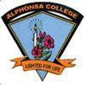

The women’s cell of Alphonsa College Pala, since its establishment in 2002, functions with the objective of promoting the all round development of the students of Alphonsa College, particularly in their capacity as young women of today by making aware of their responsibility in building the society, cultivating in them a deeper interest in the cultural heritage of our country and bringing out the best in them. Towards this end, the women Cell organizes various programmes, including talks, seminars, debates etc. The Cell endeavors to alleviate the negative forces that confront women, both within the campus and in the nearby places. The Women Cell handles issues related to women's welfare. Some of the themes which have been the focus of discussion have been concerning women’s empowerment, women’s rights, legal awareness etc. International Women’s Day is celebrated yearly with an important issue or theme in mind, to be highlighted during the programmes. Women Cell, Alphonsa College, Pala has conducted many programmes in online mode as students were not coming to college due to the Covid-19 pandemic in the academic year 2020-21. Women Cell organized various training Programmes, Seminars, invited talks, Online competitions etc

CONTENTS

Page No
OFFICE BEARERS 4
POSTER AND VIDEO COMPETITIONS - Right to live with Dignity 5
WEBINAR on PARENTING AND CHILD ABUSE 6
A POSTER COMPETITION AGAINST DOWRY 7
ESSAY COMPETITION 8
AN ONLINE AWARENESS CLASS -
MENSTRUAL HEALTH AND HYGIENE MANAGEMENT 10

WORKSHOP ON "FIRST AID" 13

AWARENESS CLASS -
THE IMPORTANCE OF MORAL, CULTURAL AND SOCIAL VALUES IN FAMILY 15 15
MIME COMPETITION – “BREAK THE BIAS” 16

Athulya – International Women’s Day CELEBERATIONS 17

SEMINAR ON CYBER - NAMMUDE PONNOMMANAKKAL- 18

AN AWARENESS CLASS ON WOMEN AND HEALTH 20

AN ONLINE AWARENESS CLASS ON
WOMEN PROTECTION LAWS AND 181 MITHRA WOMEN HELPLINE 21

OFFICE BEARERS

PRINCIPAL: DR.SR. REGEENAMMA JOSEPH

VICE PRINCIPAL REV. DR. SHAJI JOHN

DR.SR.MINIMOL MATHEW

CO-ORDINATORS : MS .TEENA JAMES
MS.SMITHA CLARY JOSEPH
NON-TEACHING STAFF : MR.BINU JOSEPH
MS. BIJIMOL JOSEPH
STUDENT REPRESENTATIVES : KUM. ALEENA MERIYA SAJI
KUM. ARYAMOL S
- Right to live with Dignity - Poster and Video Competitions in association with Anti Harassment Committee
Women Cell conducted a Poster making and 1 minute video Competitions on 27th June 2021 to promote an awareness among students on Gender Equity and also to develop a mental strength in students to raise up their voice against gender inequality.

- Parenting and Child Abuse – An extension activity in association with UBA, Department of Economics and Archana Women Centre Ettumanoor.
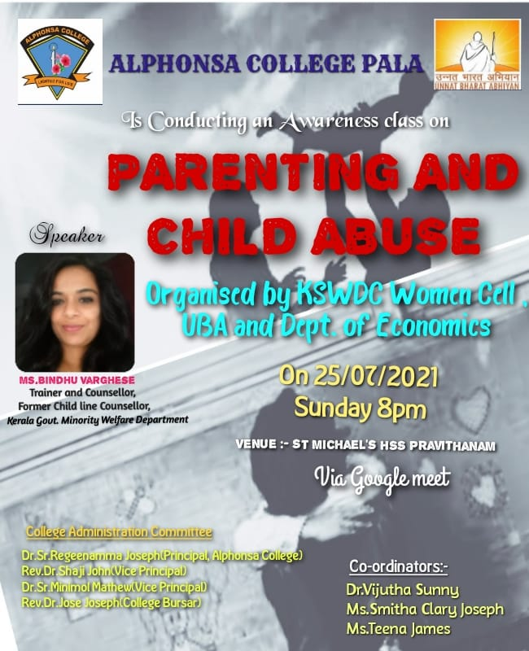
An online awareness class on "Parenting and Child Abuse" to parents of St. Michaels Higher Secondary School, Pravithanam. Class lead by Ms. Bindhu Varghese, Trainer and Counsellor, Former Childline Counsellor, Kerala Govt. Minority Welfare Department was conducted on 25th July 2021.
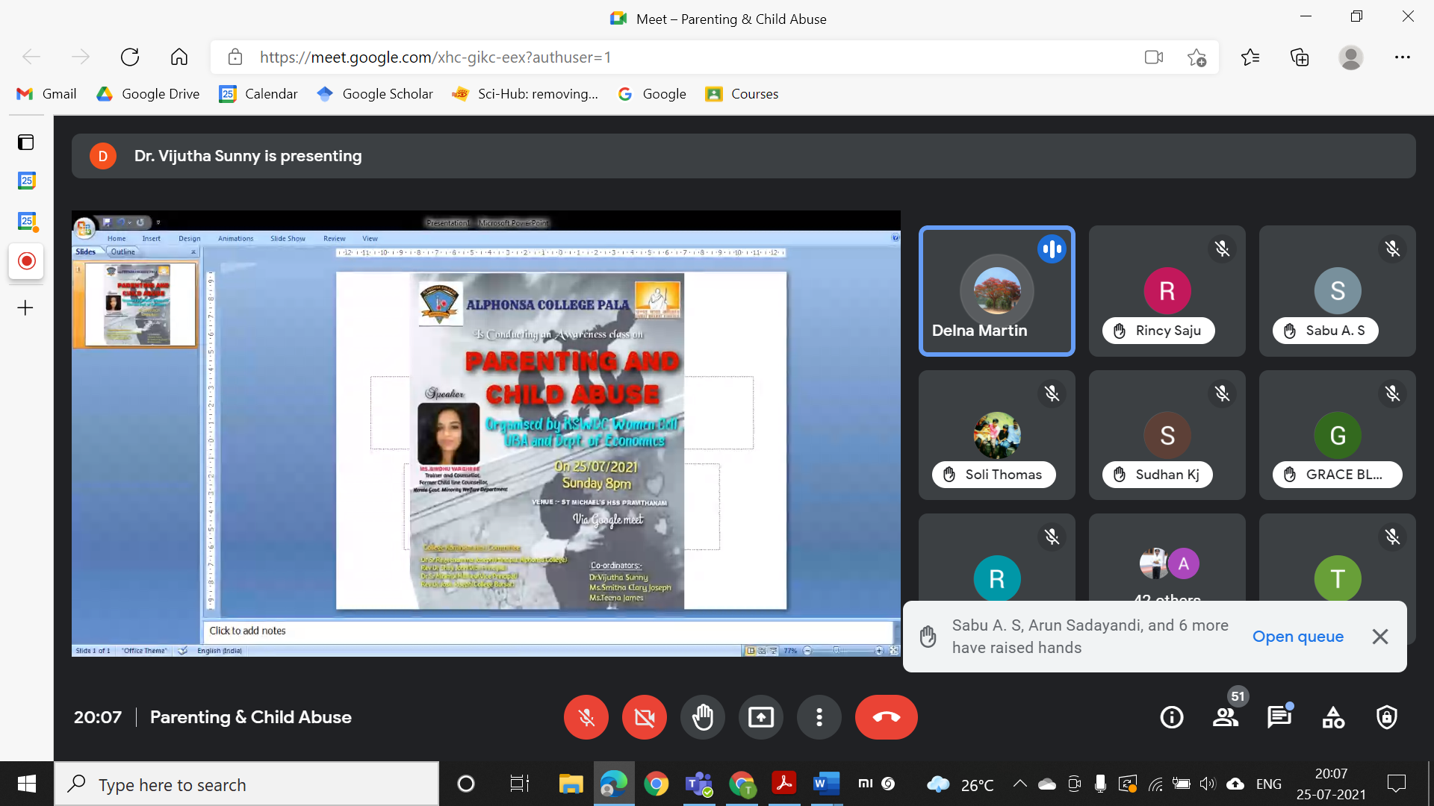

- No to Dowry - Poster competition
A poster competition was conducted according to the order given from MG university, to promote awareness about the bad effects of Dowry in the current scenario on 7th September 2021.
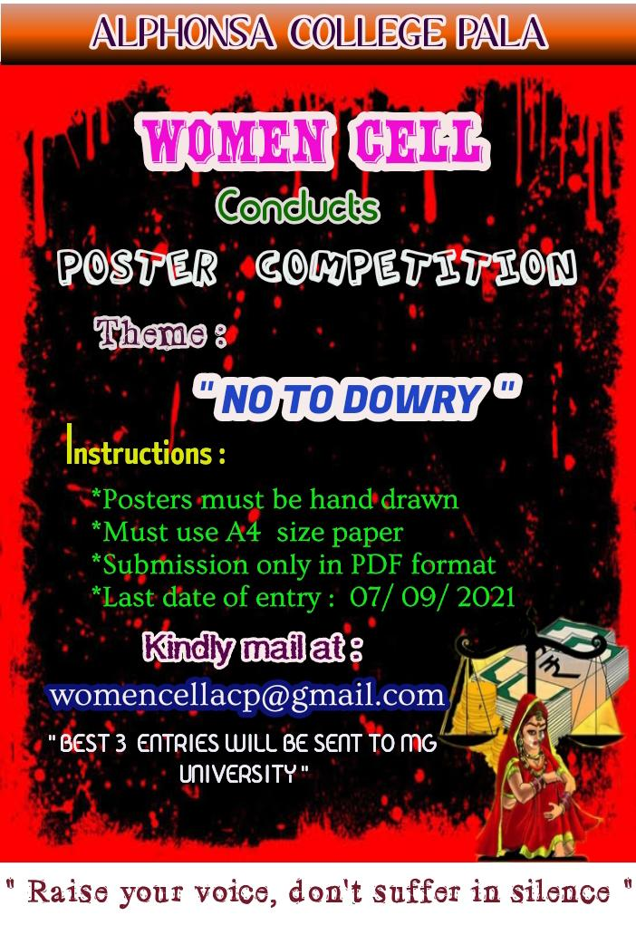

- ssay Competition E - Topic: “Sthreedhanavum Sthreeku avakashapetta swathum sthree vendannu vekkendathundo?” on 25th September 2021

- 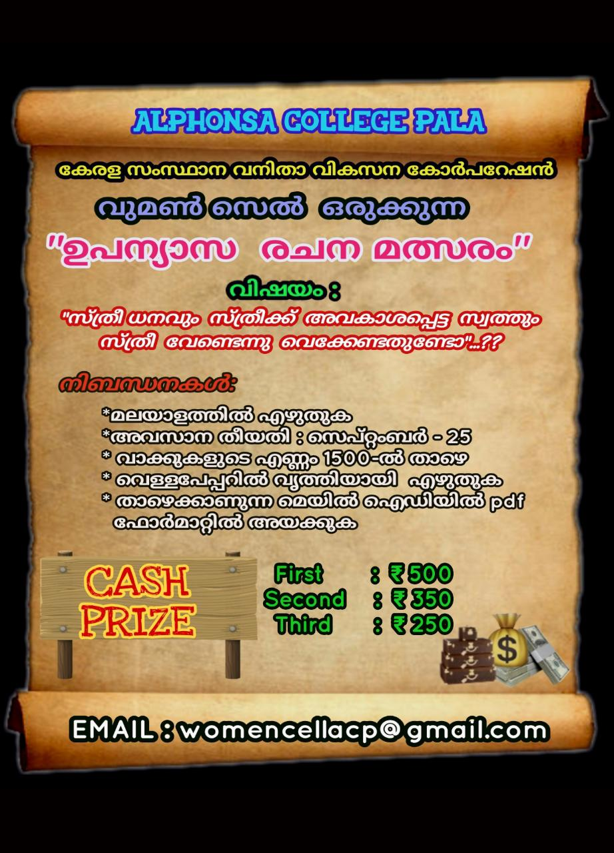

- Menstrual health and hygiene management – An online class in association with Unicharm India

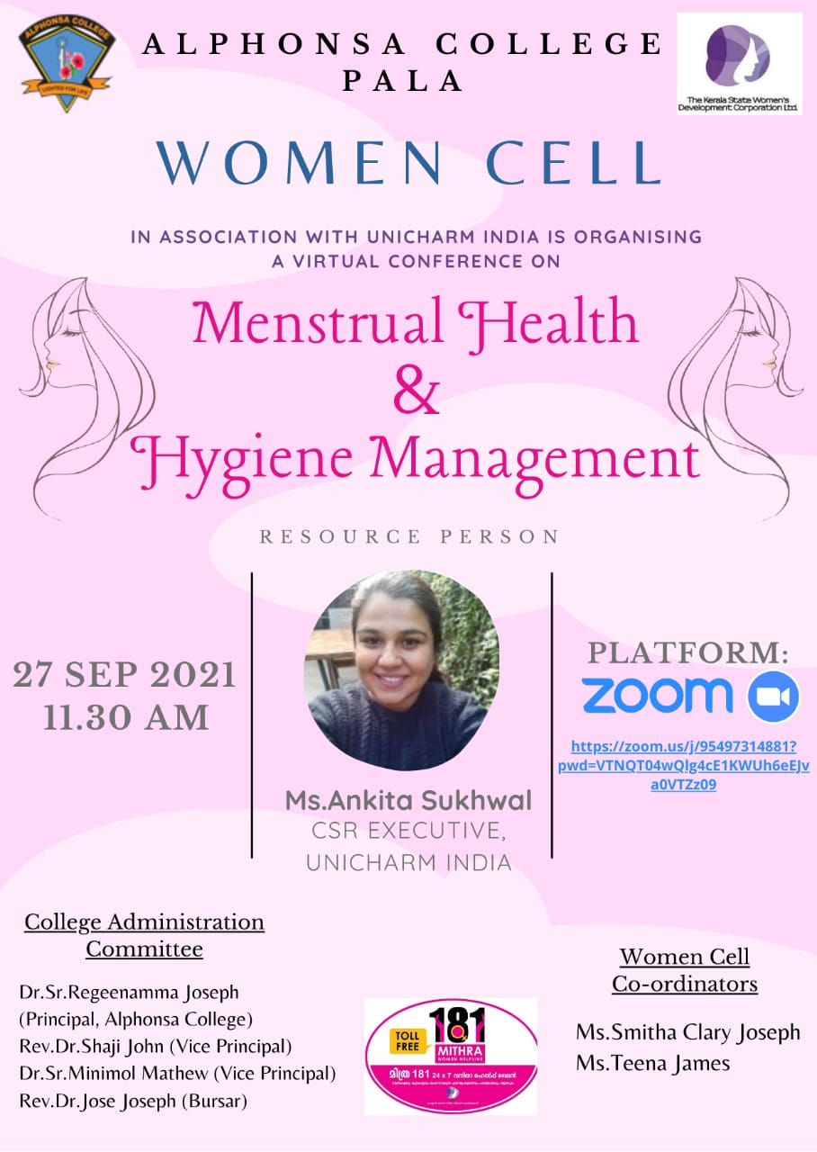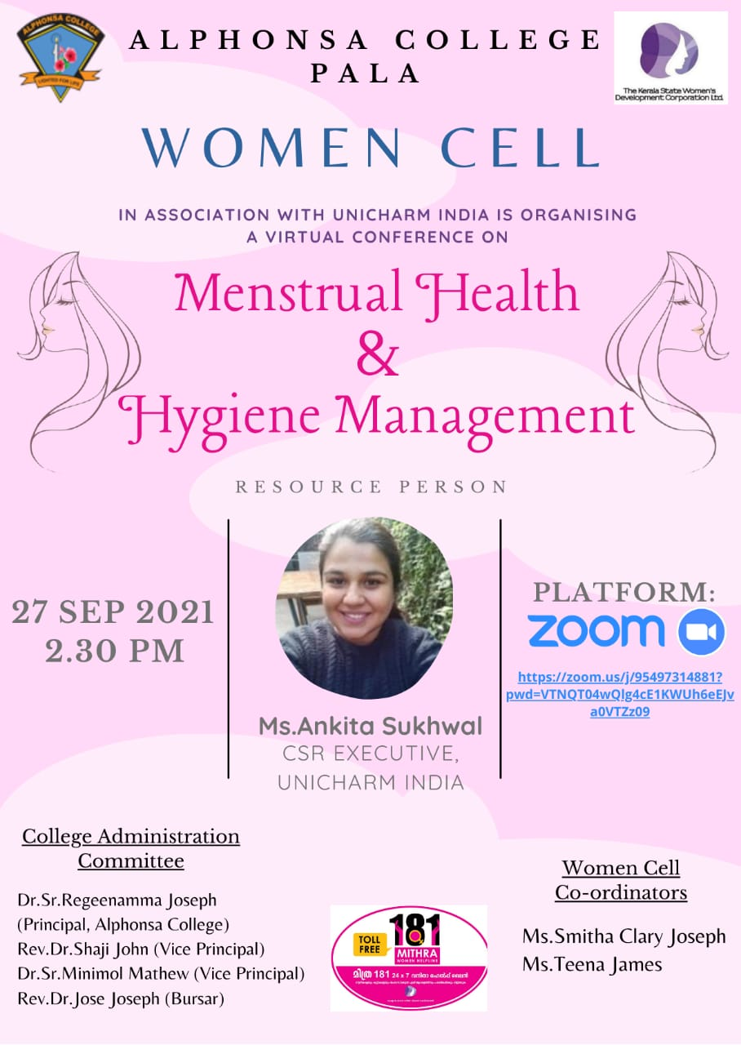

Virtual conference separate session was held for science and arts students of our college on 27th September 2021. Ms. Ankita sukhwal,CSR executive unicharm India handled both the sessions and the students benefitted a lot from the class.

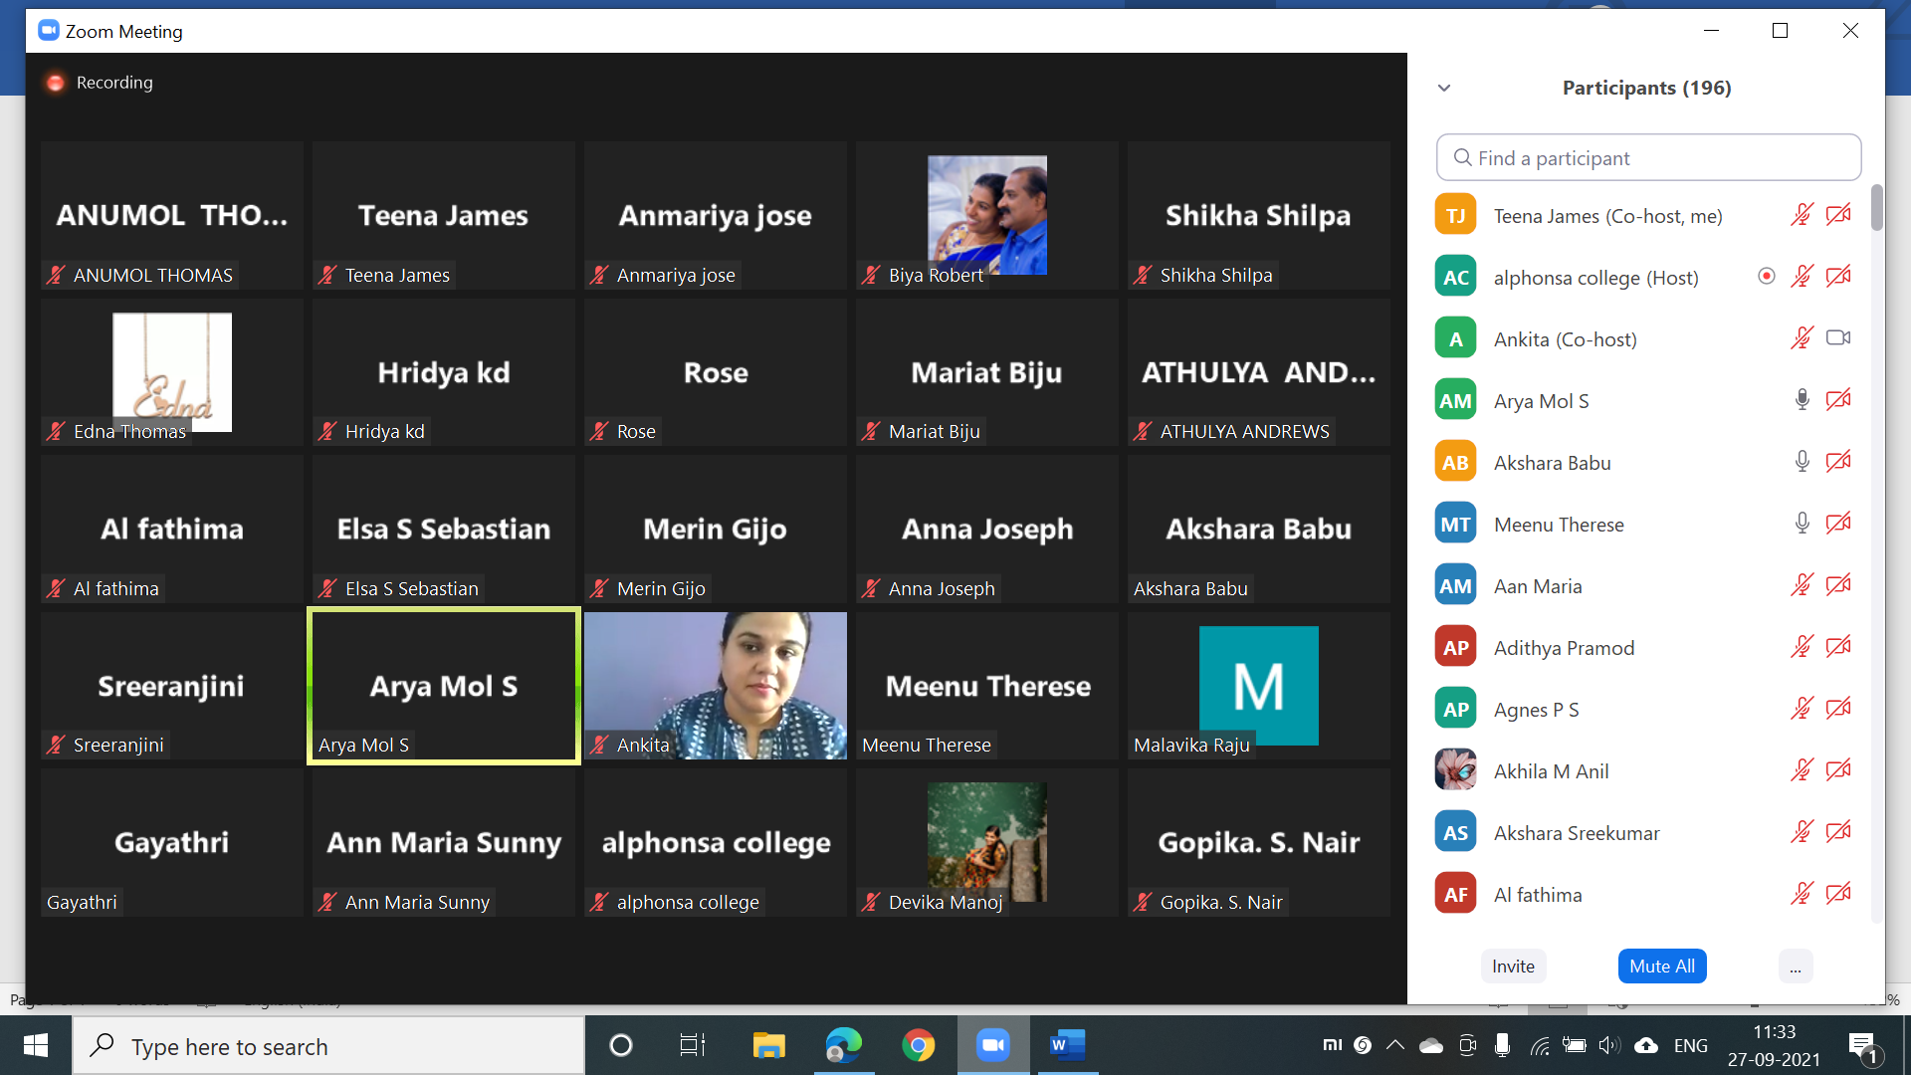
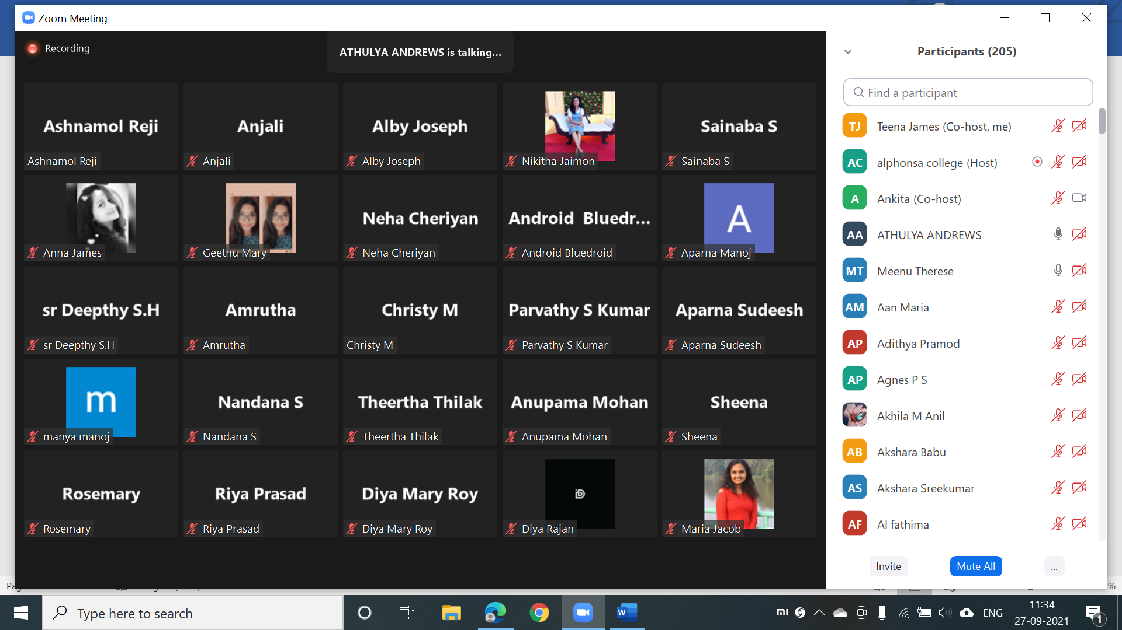
- Menstrual Hygiene – An extension activity in association with UBA and Dept of Zoology
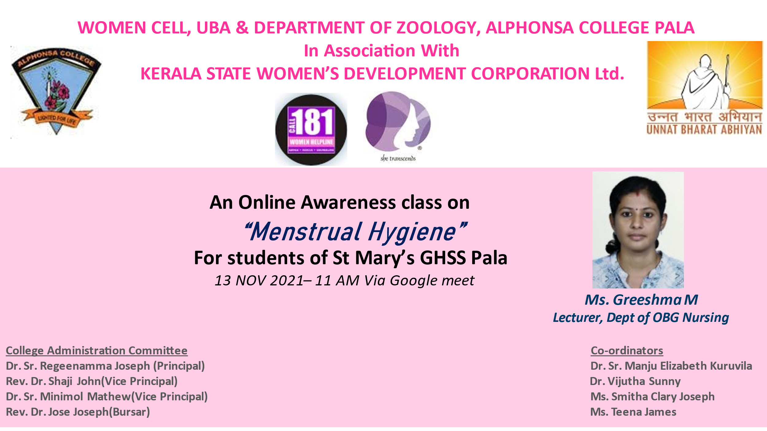
An online awareness class for students of std IX of St. Mary's GHSS Pala, in online mode on Google meet conducted on 13th November 2021. The students actively participated by clarifying their doubts and sharing the problems they face. Ms. Greeshma M, Lecturer , Dept of OBG Nursing, LLM Hospital Kidangoor

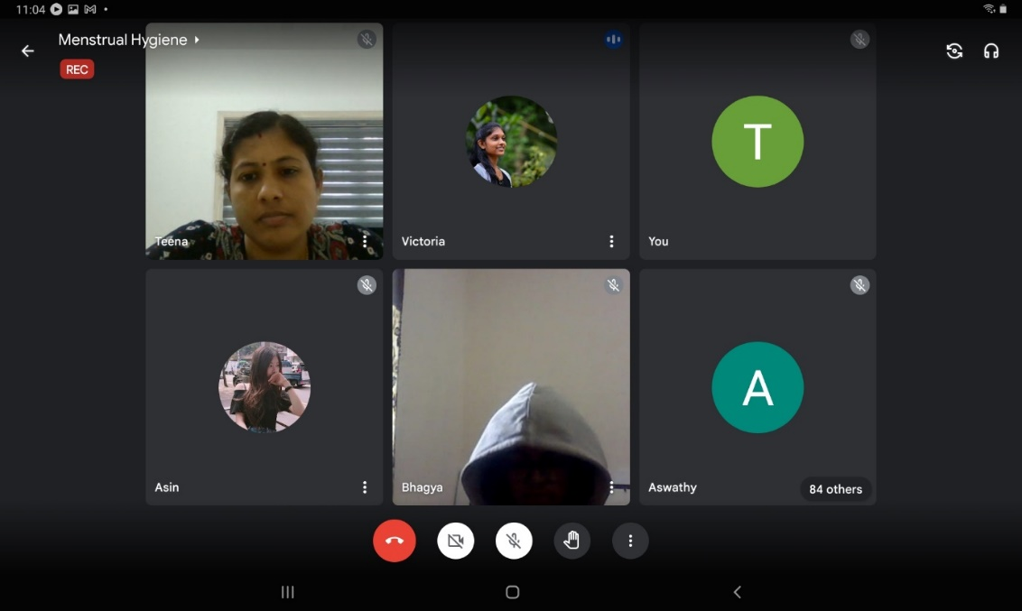
Workshop on "First Aid" 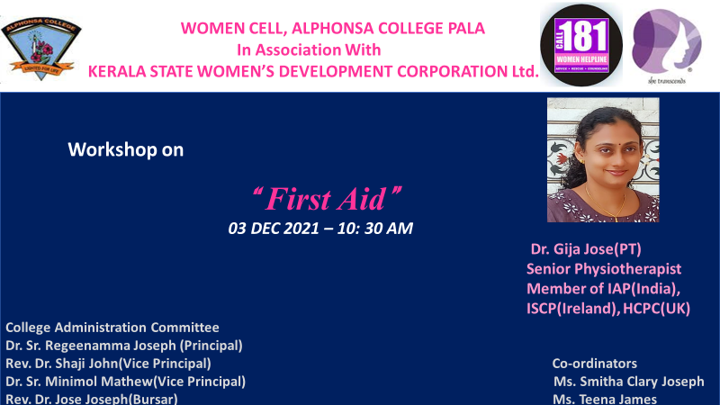

A workshop was conducted for Women Cell Members of our college for giving training on First Aid on 3rd December 2021. Dr. Gija Jose, Senior Physiotherapist and member of IAP(India), ISCP(Ireland) and HCPC (UK) handled the sessions
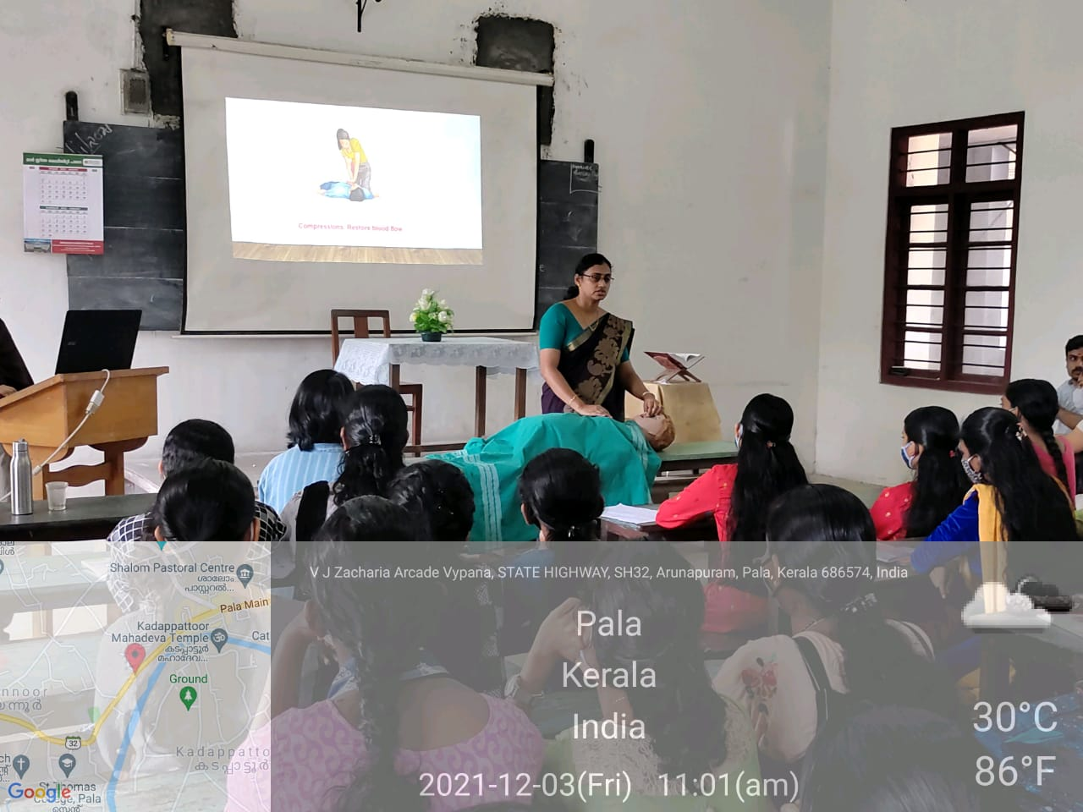

Positive Mental Attitude Development Training Programme - Capacity Enhancement Programme conducted on 22nd February 2022
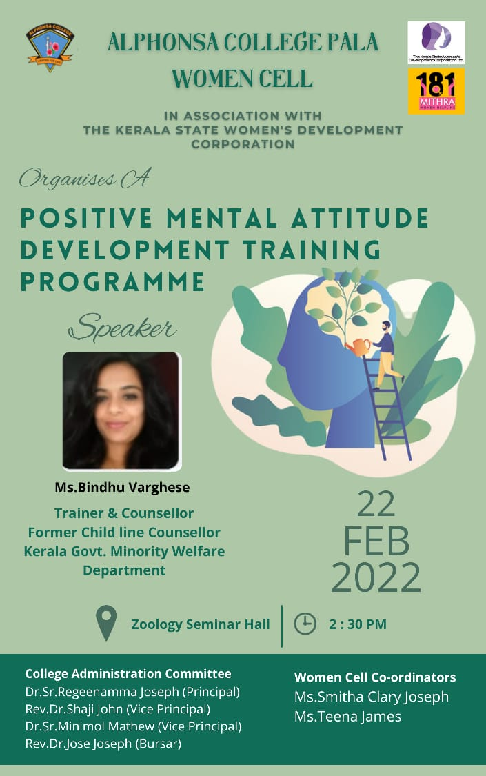
A training session was given to our students on how to develop a positive out look in their day today lives. 50 students participated. Ms Bindu Varghese, Trainer and Counsellor, Former Child line counsellor, Kerala Govt. Minority Welfare department was the resource person for the session. The session was very interesting with active participation of students.
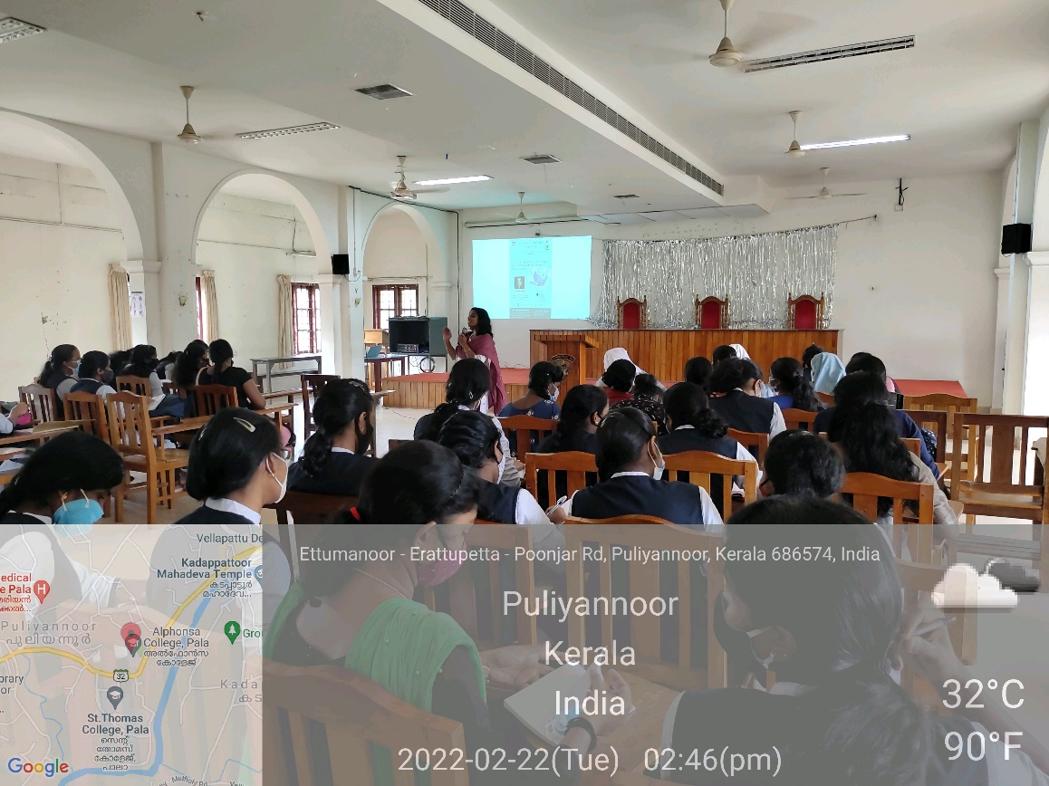

The Importance of Moral, Cultural and Social Values in Family - Moral Education class in association with the Department of Zoology

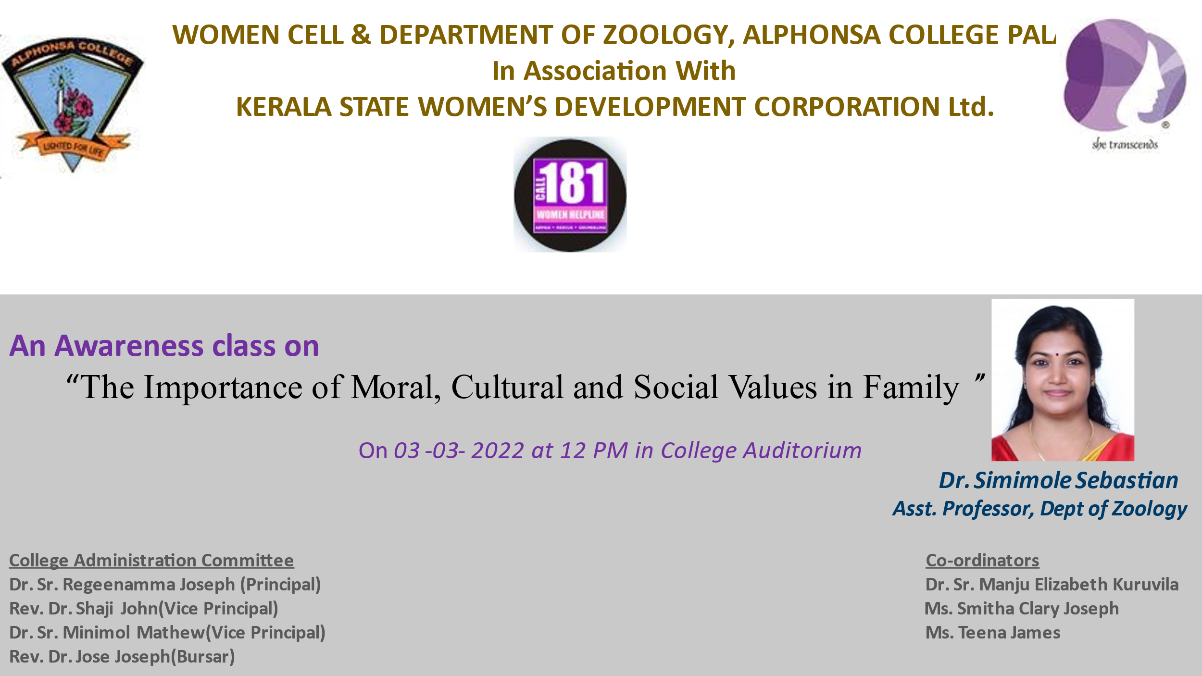

To keep up the values we have inherited from our heritage and to pass it into next generation, women cell has conducted a moral education class on 3rd March 2022 with Dr. Simimole Sebastian, Asst. Professor, Department of Zoology as the resource person.
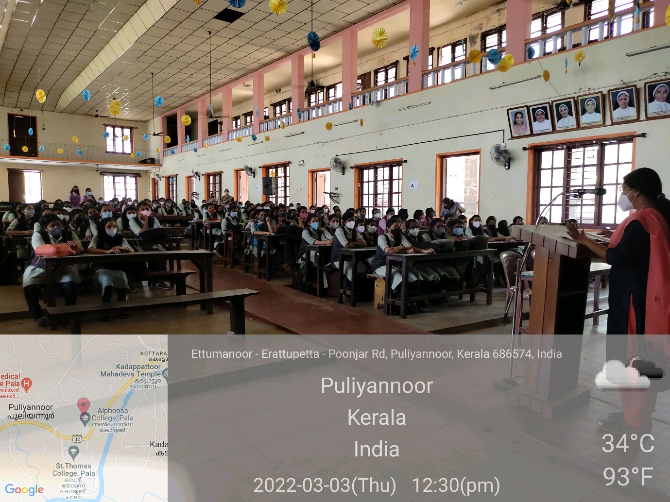

Mime competition – Topic “Break the Bias”
As part of International Women’s Day celebration a Mime competition was conducted on 8th March 2022.

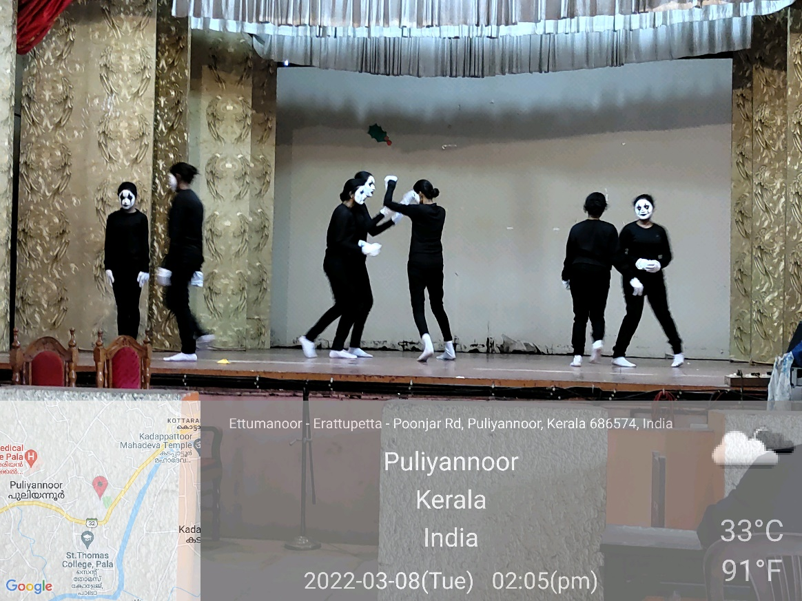

Athulya – In connection with International Women’s Day along with Social Justice Forum, a meeting of Women was conducted on 10th March 2022.

Fifty eminent women personalities were honoured, it included teachers, students and women with outstanding performance in various fields other than academic field.
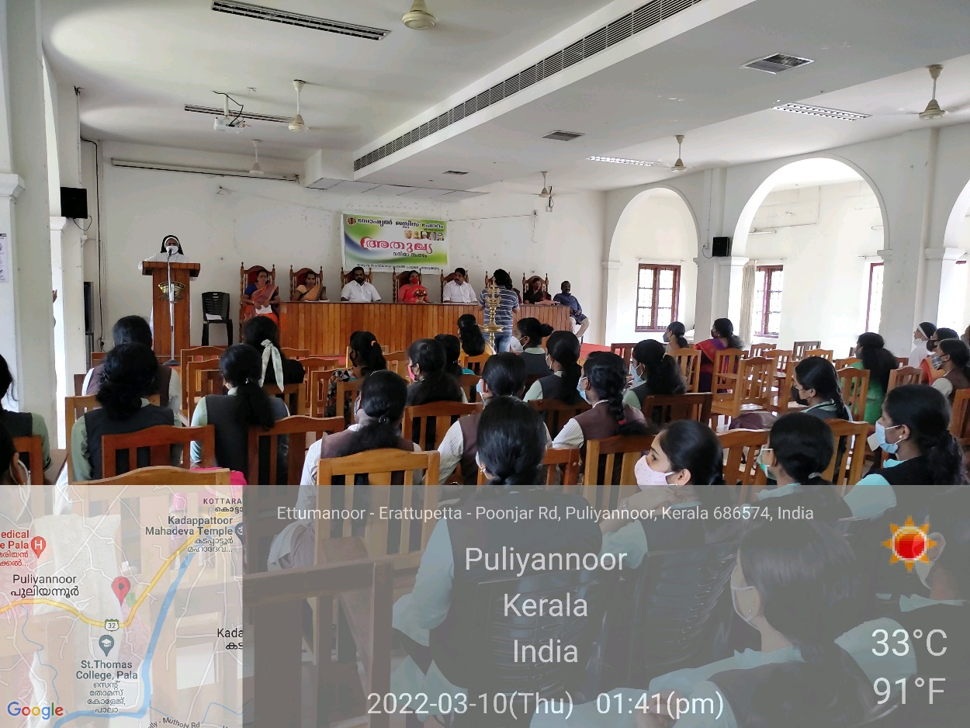

NAMMUDE PONNOMMANAKKAL-

Women cell in association with Pala Police and NSS organised a seminar on Cyber Security on FEB 25TH 2022.Dr.B Sandya IPS (DGP DIRECTOR FireForce )inaugurated the programme ..Dr.Sr.Regeennamma Joseph Principal presided over the function.Sri S Sureshkumar Additional SP Kottayam, Sri.Shaju Joseph DYSP Pala carried on the felicitation.,which was followed by an awareness class by Ragesh Manimala ,Officer Kottayam Crime Branch in which he exhorted the students to be aware of the risks that they can face with online activities and how to ensure security of networks.

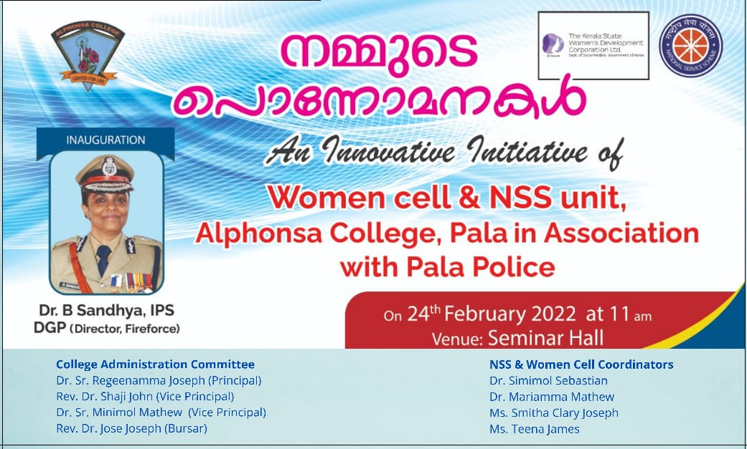
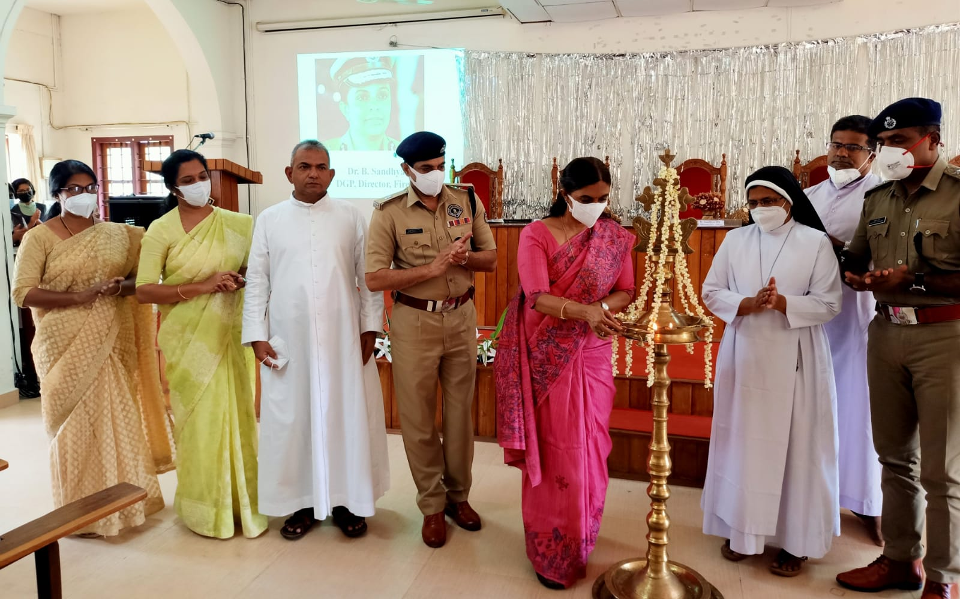

- An awareness class on Women AND Health was organised by women cell in association with the Department of English on march 8th 2022,Dr.Anit Antony ,Consultant Rehabilitation Physician ,General Hospital Pala handled the class

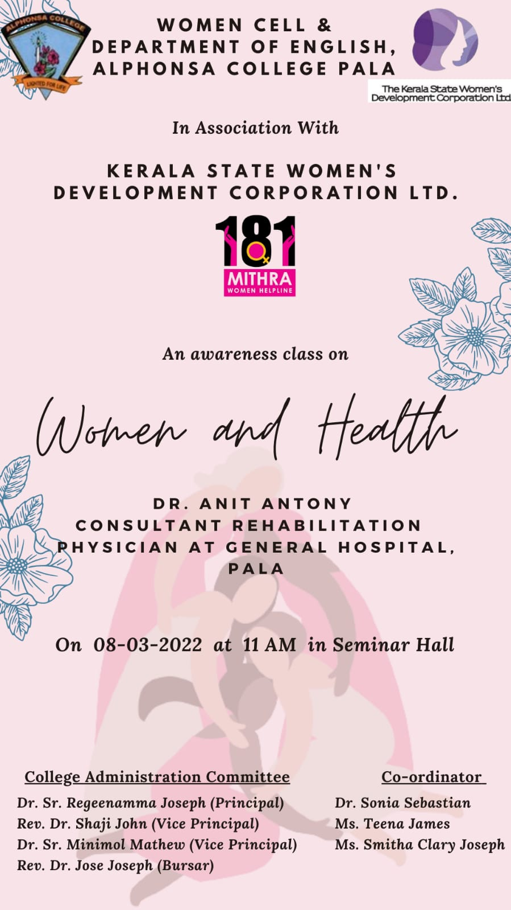

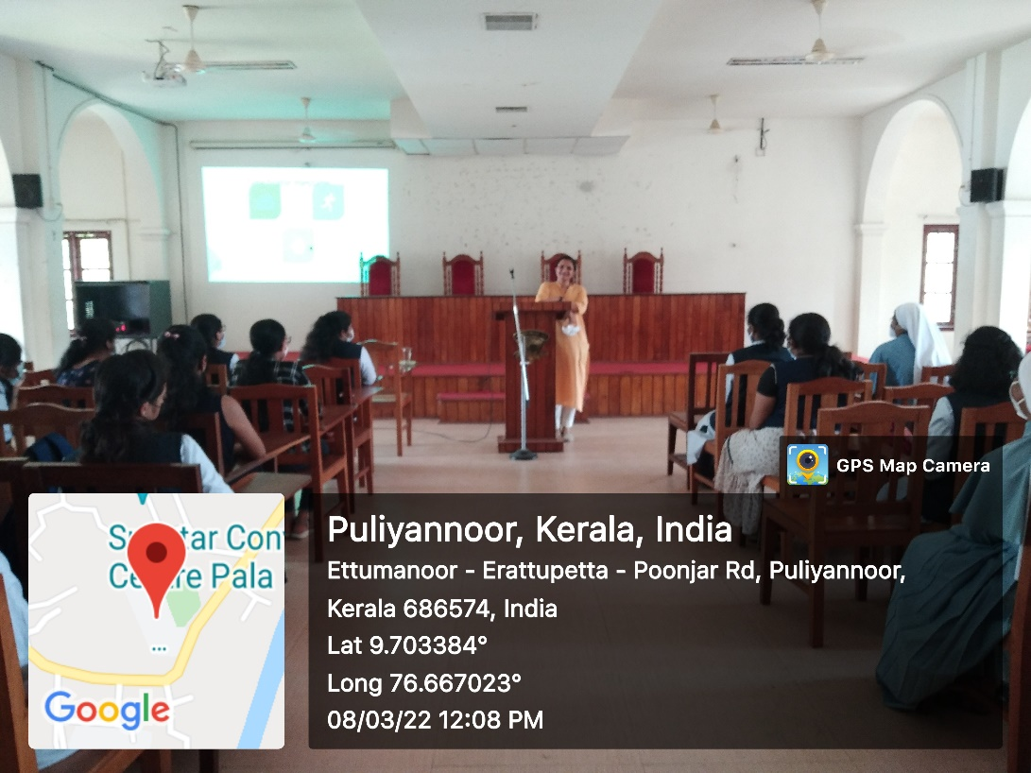

- 181 WHL Awareness Class

An online awareness class on women protection Laws and 181 Mithra Women Helpline was conducted on 26th March 2022. Adv. Drishya V K, Team Member of 181 WHL lead the class. The class was very
informative.

