GENDER EQUITY PROGRAMMES
2020-21
Webinar on Red is the new blue-16-August-2020
NSS unit in collaboration with the Red Cycle organized a webinar on ‘Red is the new Blue: busting myths and misconceptions on menstruation’ by Mr. Arjun Unnikrishnan conducted on 16 th August 2020.
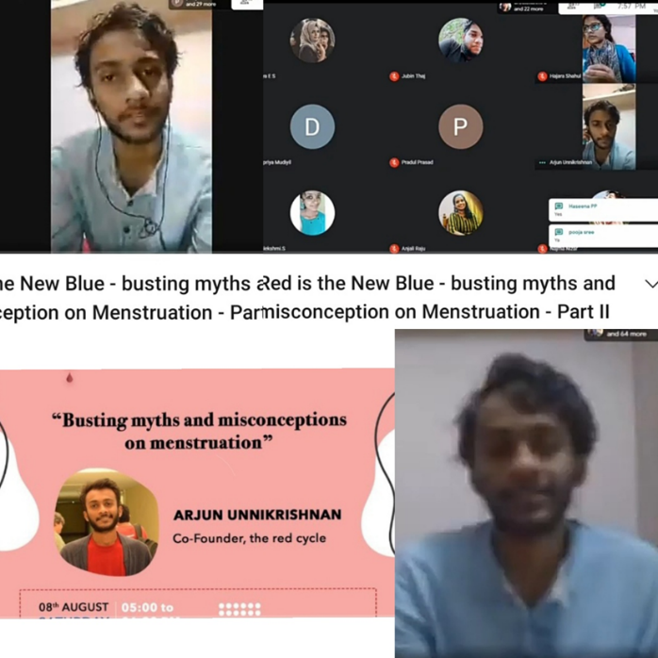

Women Equality Day-26-August-2020
The NSS unit organized a webinar in connection with Women Equality Day. Lt. Anu Jose, Asst. Professor of Alphonsa College led a session on “Samadarshan”

Gender Sensitisation Webinar on 7-October-2020
NSS organised a Gender Sensitisation webinar on the “ആഴമുള്ളപെൺപറക്കങ്ങൾ :Gender Sensitisation” by Dr. Mini Sebastian, Asst. Professor, Dept. of Malayalam, Devamatha college was conducted on 7th October 2020. Gender Sensitization is a basic requirement to understand the sensitive needs of a particular gender. It helped the volunteers to examine their personal attitudes and beliefs and question the ‘realities’ they know.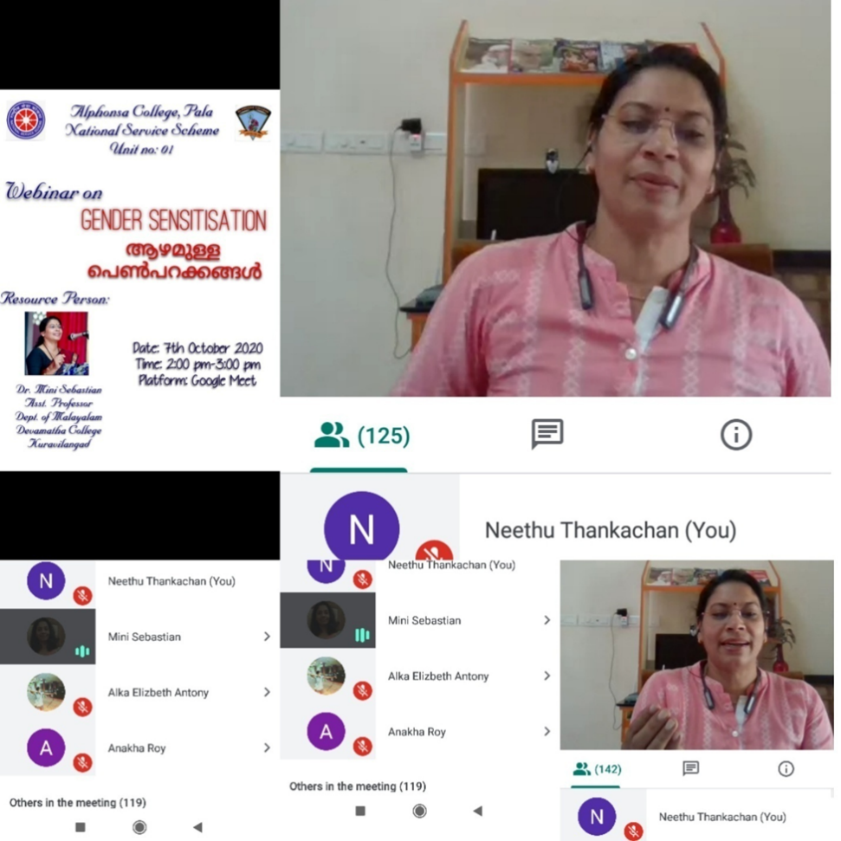
International girl Child Day-11-October- 2020
International girl Child Day was observed on 11th Oct 2020 by NCC. Posters were made to raise awareness on the rights of the female child and the need to stop female foeticide.
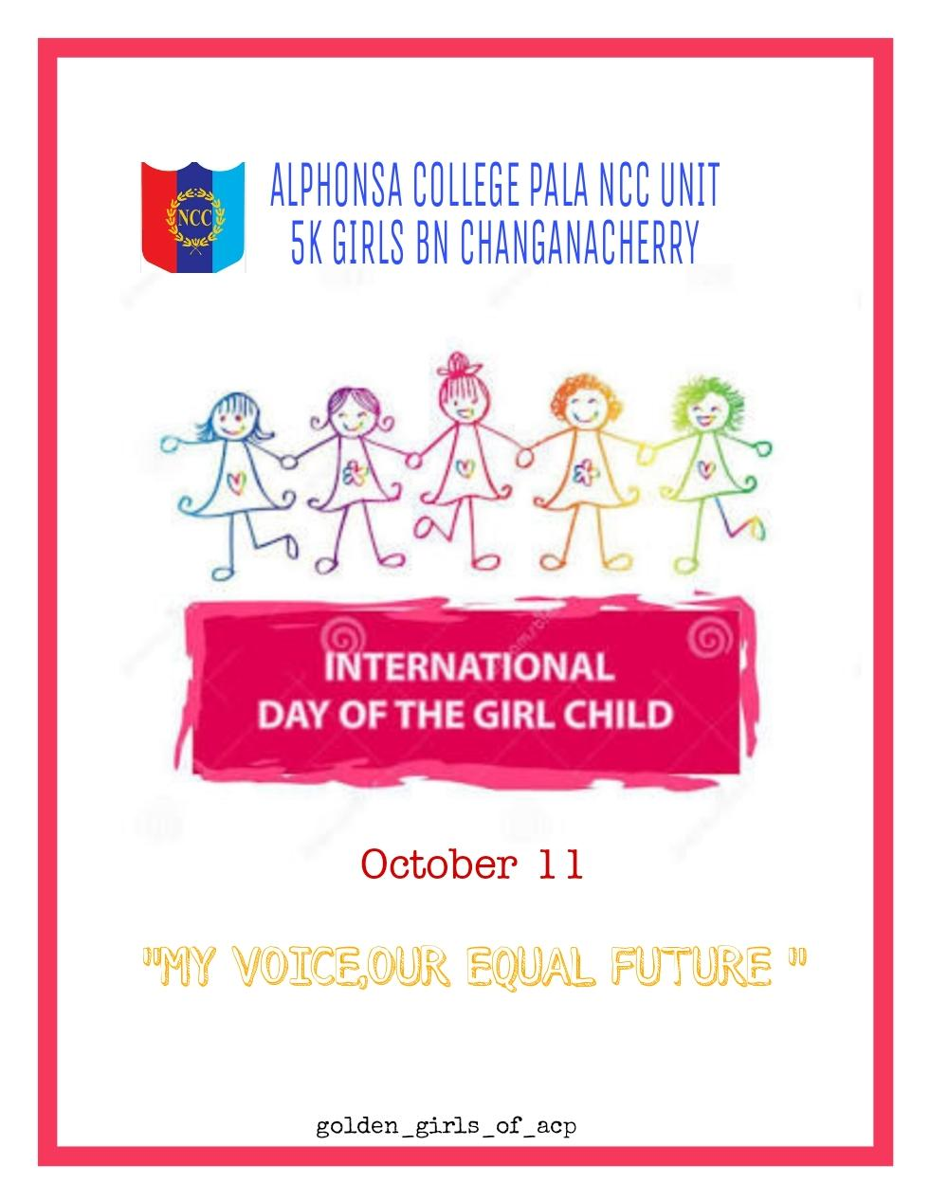
Rural women empowerment-15 to 21-October-2020
As part of International Rural women empowerment Day, NCC launched one week rural women empowerment challenge from 15 October to 21 October 2020. Training was given to rural women by the cadets on Garment Making, Basic Office automation tools and in the use of e payment wallets. 62 cadets participated. 65 women benefitted by the training.
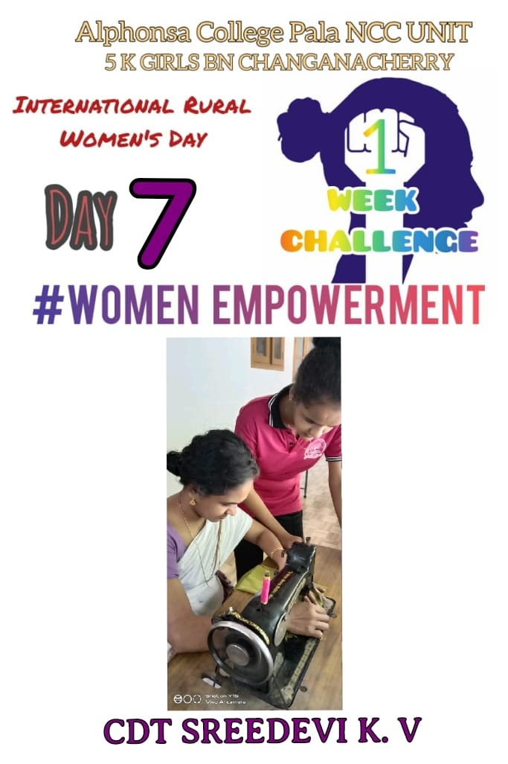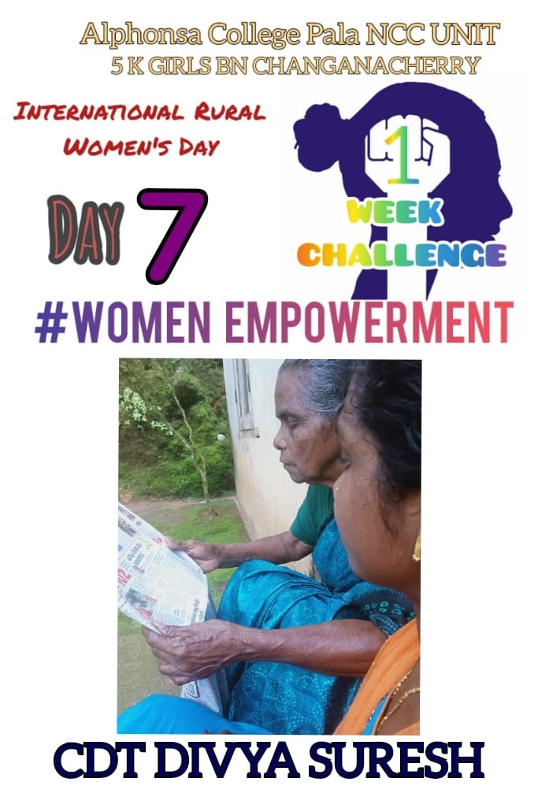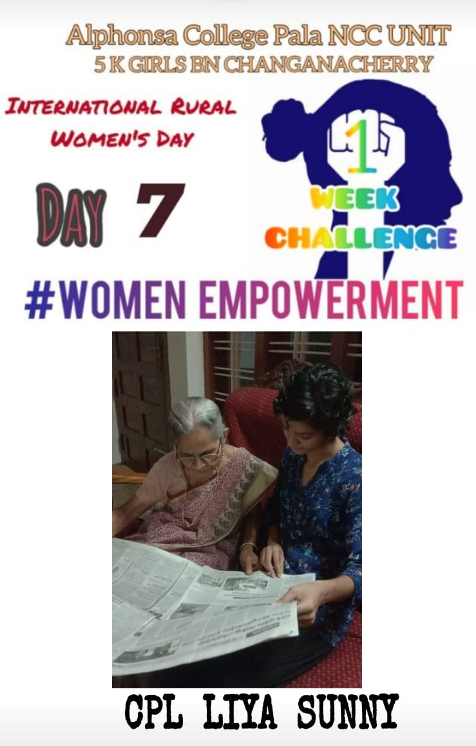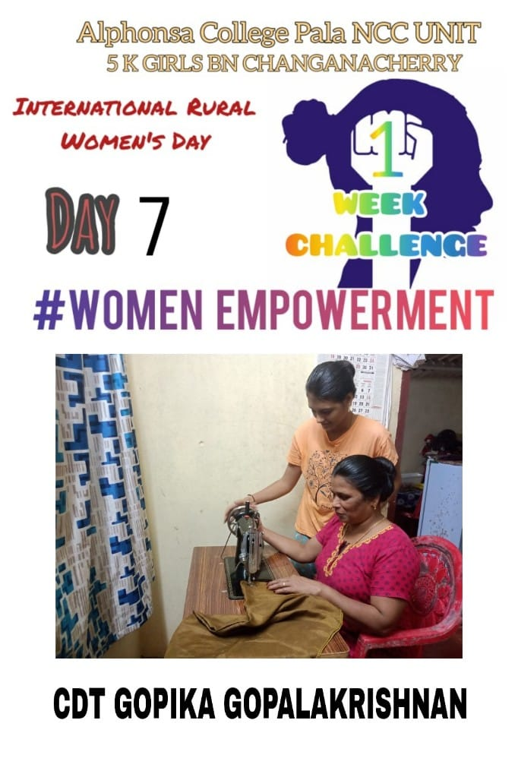

Fit India event-To make them fit and bold-WEBINARS-6 & 17 September-2020
As part of the Fit India event, NCC and NSS Units of Alphonsa College was jointly organized a webinar on ‘Physique and Physical Fitness’ was held on September 6, led by Ms.Susan Florentina S. Another class was organized on 'Essentials of Disciplined Physique' by Mr. Amal Manohar Manohar, fitness trainer and national athlete, on 17 September 2020.
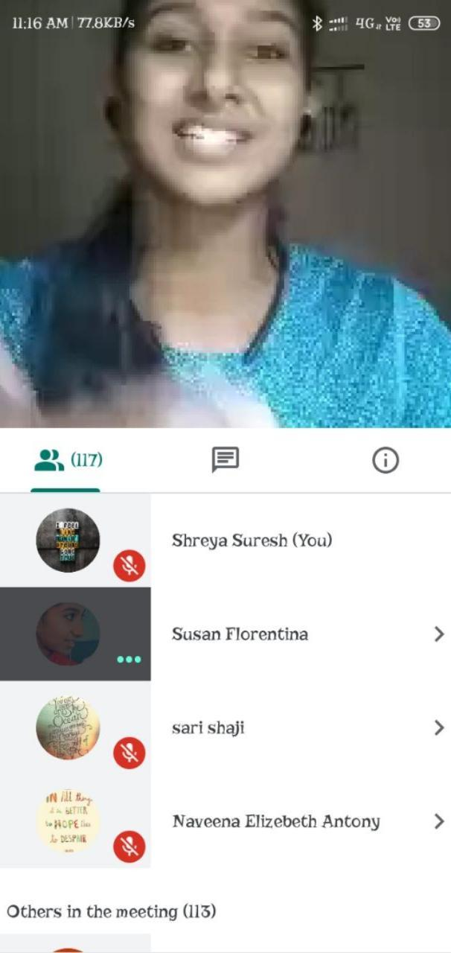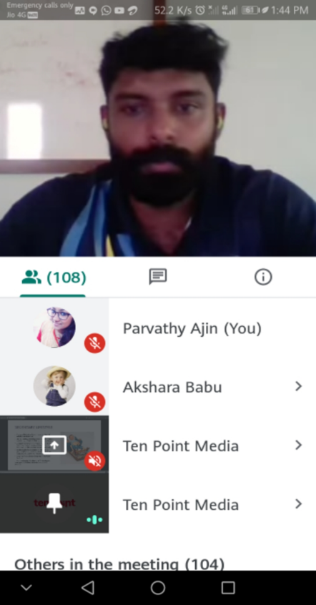

Invited talk ‘Women in Science’ on 14-November-2020
Department of Physics organized an invited talk on the topic ‘Women in Science’ on 14/11/2020 by Dr. Chitra Nayak, Associate Professor, Tuskegee University, USA.
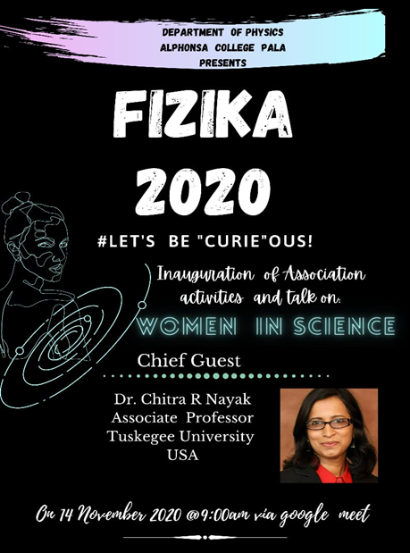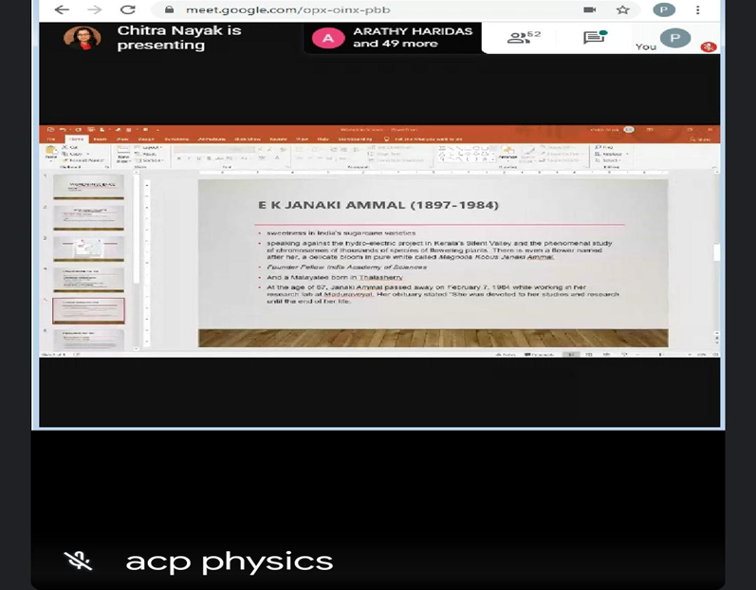

Webinar- “Gender equality and women’s empowerment”-5-January-2021
Women Cell organized a webinar “Gender equality and women’s empowerment” on 5-1-2021 by Dr. Maya Shibin, Consultant Psychologist.
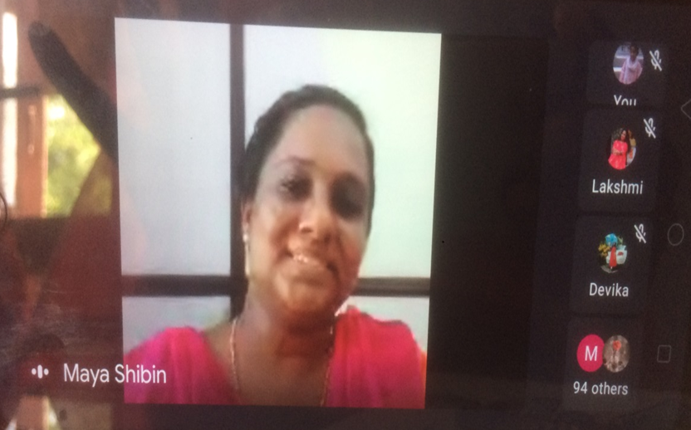
International Day of Women and Girls in Science-11-February 2021
As part of International Day of Women and Girls in Science, NSS unit conducted a video competition and an interactive session in Google meet on February 12.

World Social Justice Day-20 & 21- February 2021
NSS unit organised a debate competition on ‘Justice for Gender’ on 20 February 2021. In association with Lions club 318b, NSS unit conducted a mega webinar on February 22 on ‘Legal Awareness’. The session was taken by Adv. Usha Menon.
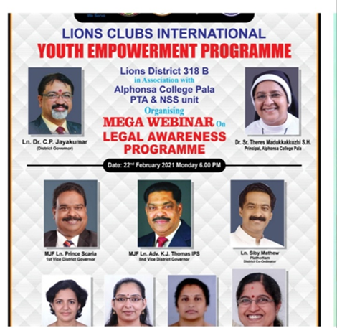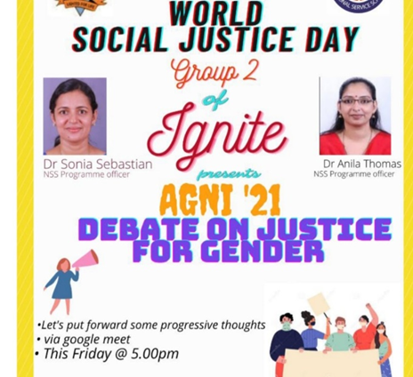

International Women’s Day-8-March -2021
International Women’s Day is observed globally every year on 8 March to celebrate the social, economic, cultural, and political achievements of women.
As part of International Women’s Day Celebration, the College Union Organised an Online Webinar on ‘Menstrual Hygiene: Let’s Cup the Myths’ by Ms. Swathy Jagdish, Lactation Counsellor and Sexuality Health Educator on 15th March 2021. The webinar was conducted in Zoom platform. Most of our students participated in the webinar and cleared their doubts regarding the use of menstrual cup and its usage.
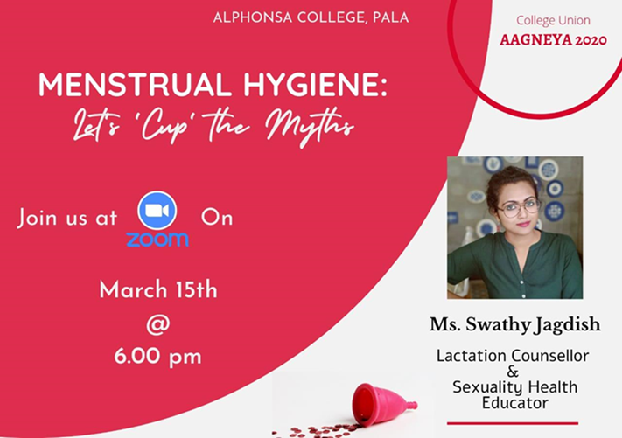

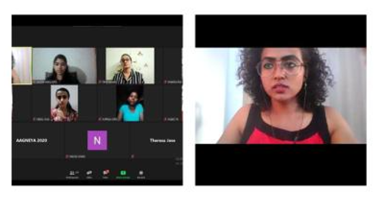
Department of Chemistry organized an webinar the topic ‘Youth and Mental Health: challenges ahead’ on 14th march 2021 by Dr. Lakshmi Lal who is currently doing her MD in ayurvedic psychiatry. The talk really helped the students to overcome their mental stress, to reduce exam fear and how to prepare for exams.
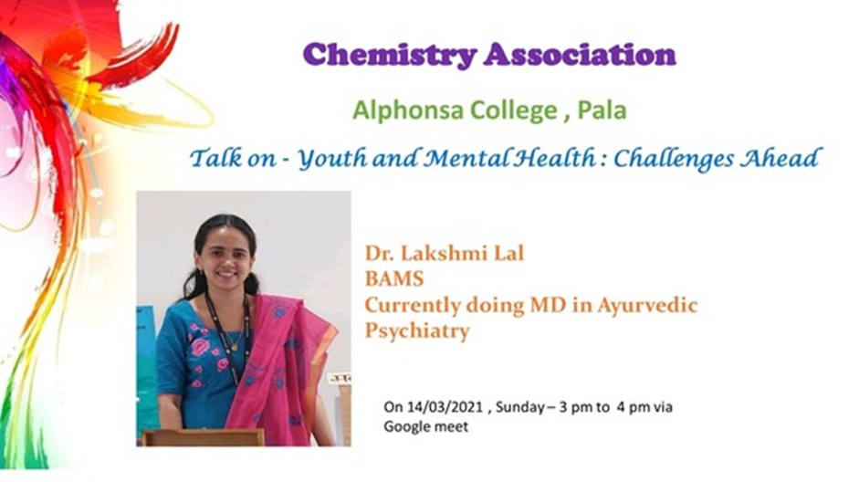0

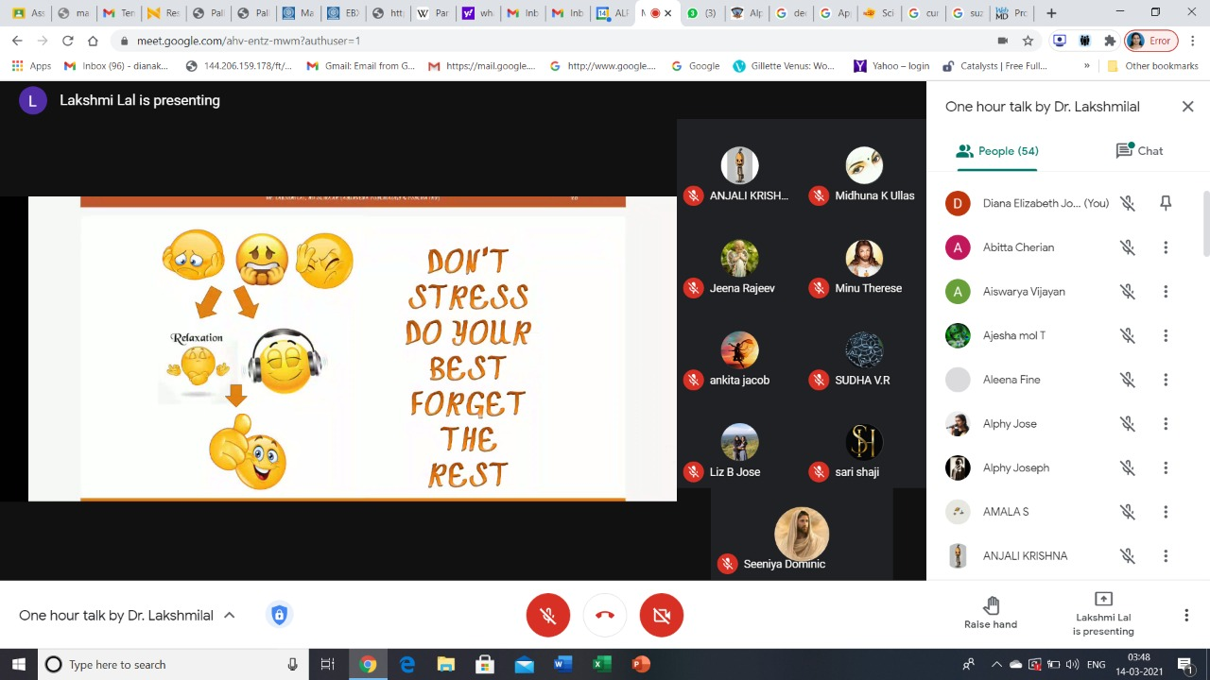

Department of History conducted a lecture on ‘Women Entrepreneurship’ on 12 March by Ms.Elsa Rose George, Faculty of diploma in Entrepreneurship.
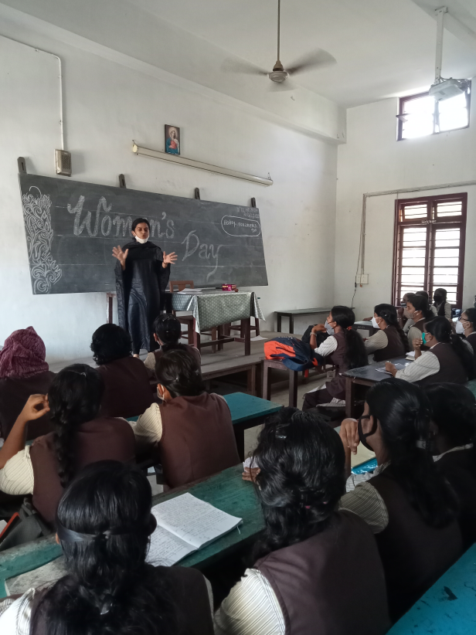
Women Cell organised webinar on “Problems of Women in the present Scenario and solutions” by Sr. Ancy Kaduppil on March 8 and “Laws for women in India’ by Adv. Teena Cherian (High Court Ernakulam) on March 10.
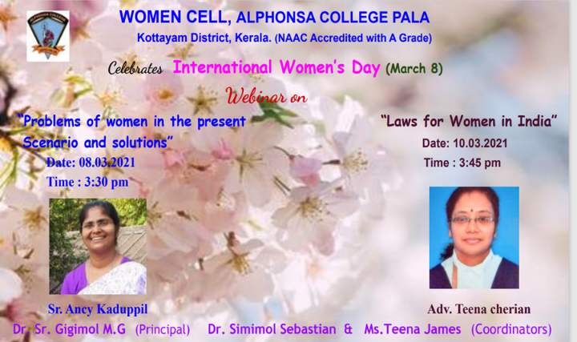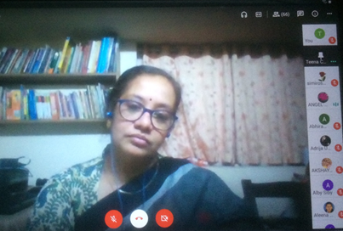
Department of Economics celebrated Women’s Day by conducting an webinar on 8 th March. Department History conducted an invited lecture by Ms. Elsa Rose about Women Entrepreneurship.
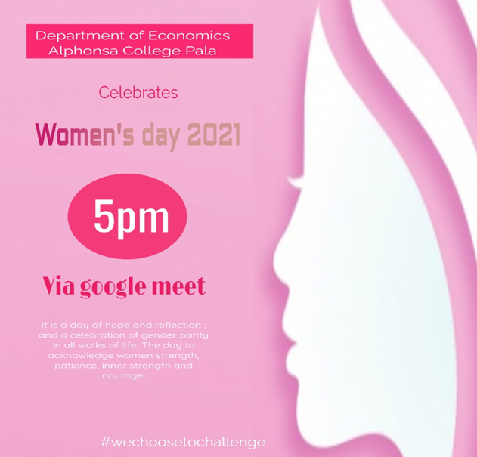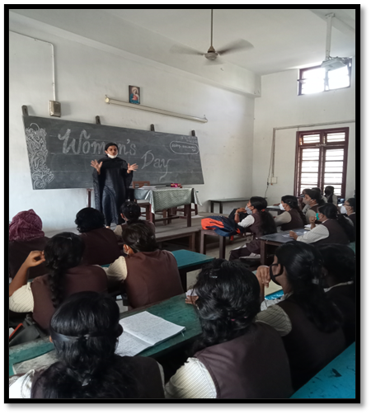

As part of International Women’s Day NSS organised a webinar on the topic “Modern Women Talking” which was headed by Ms Rosemary Philip (Assistant Professor, Department of English, Alphonsa College, Pala) on March 13 and conducted a selfie with super women- competition.
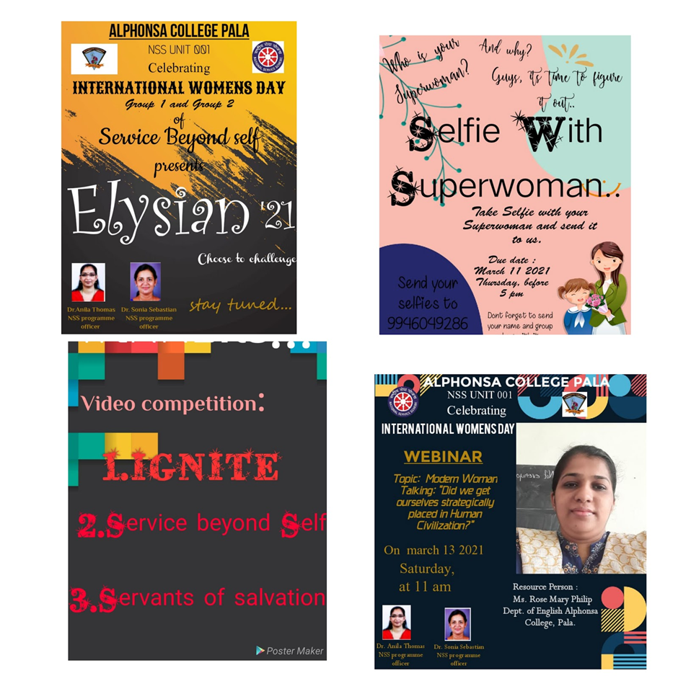

Workshop on Women Entrepreneurship (24-26 March 2021)
Department of Economics organized workshop on Women Entrepreneurship from 24-26 March 2021.
Resource person- Nirmala Jimmy (District Panchayat President), Mrs. Sherly Regimon (Chief guest; CEO of Milan). An online session was also conducted by Ms. Mary Sebastian and Mr Santhosh Kumar Saha from UGC-NSQF-MEPSC.
Classes taken by following resource persons-
Rani Thomas (Regional Manager, Catholic Syrian Bank), KC Thankachan (VICIB), and Ambily VKVK Tailoring centre Manimala, Ruby Thomas (Entrepreneur), Jose Joseph Cheruvallil (Entrepreneur), and Sruthy Krishna (Entrepreneur), Maggi Menamparampil (Entrepreneur), Sri. Varghese Paul(Centre for Alternative Learning and Living, Chalakkudy).
